
RAMAIAH
INSTITUTE OF TECHNOLOGY
USN | 1 | M | S

(Autonomous Institute, Affiliated to VTU)
(Approved by AICTE, New Delhi & Govt. of Karnataka) Accredited by NBA & NAAC with ‘A’ Grade

SEMESTER END EXAMINATIONS – JANUARY 2018

Course & Branch | : | B.E. : Electrical and Electronics Engineering | Semester | : | VII
Subject | : | Power Systems - II | Max. Marks | : | 100
Subject Code | : | EE702 | Duration | : | 3 Hrs

Instructions to the Candidates:
- Answer one full question from each unit

 |  |  | UNIT – I
1. | a) |  | The oriented graph of a system is shown in Fig (1.a), obtain basic cut set incidence matrix B, basic loop incidence matrix C and branch path matrix K. Select elements 5, 6 and 7 as links. Hence verify the relation 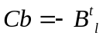  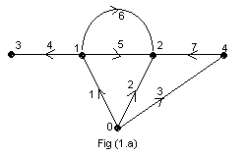 | CO1 | (10)
 | b) |  | Derive the step-by-step algorithm for formation of bus impedance matrix, when added element to the partial network is link. | CO1 | (10)
2 | a) |  | Compute the bus admittance matrix for the power shown in Fig (2.a) by using singular transformation.  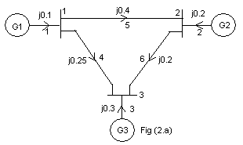 | CO1 | (10)
 | b) |  | For the power system of Fig. (2.b) with Bus 1 as reference and line data impedances are in PU. Compute bus impedance matrix using building algorithm. Add the elements in the 1-2, 2-3 and 1-3.  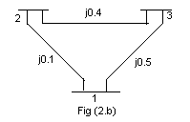 | CO1 | (10)
 |  |  | UNIT – II
3. | a) |  | What is load flow problem? Explain in detail the different types of buses in a power system. Discuss the significance of slack bus in the load flow studies. | CO2 | (10)
 | b) |  | Using NR method, determine the values of X₁ and X₂ after one iteration. Given that ,. | CO2 | (10)
4. | a) |  | Derive the necessary formula for load flow analysis using Gauss Seidel method for the power system having all types of buses. | CO2 | (10)
 | b) |  | Obtain the model for Fast Decoupled load flow method and hence derive all the necessary formula also state all the assumptions made. | CO2 | (10)
 |  |  | UNIT – III
5. | a) |  | Two units 1 and 2 each of 200MW, supply a constant load of 300 MW. The fuel costs are as follows with P_{G} in MW and the cost in RS/Hr IC₁=0.1P_{G1}+20 and IC₂=0.12P_{G2}+15. Determine the most economical division of load between the two units. | CO3 | (04)
 | b) |  | Write brief note on unit commitment along with the problem formulation. | CO3 | (06)
 | c) |  | Compute the loss coefficients for the network shown in Fig (5c). Using the given data:  I_{a}=1.0-j0.15 PU Z_{a}=0.02-j0.15 PU  I_{b}=0.5-j0.10 PU Z_{b}=0.03-j0.15 PU  I_{c}=0.2-j0.05 PU Z_{c}=0.02-j0.25 PU  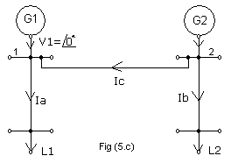 | CO3 | (10)
6. | a) |  | Derive an expression for transmission loss formula. | CO3 | (10)
 | b) |  | Given that the incremental costs of two plant units are  IC₁=0.008P₁+8.0 Rs/MWh and IC₂=0.0096P₂+6.4 Rs/MWh. Determine the economic operation schedule and corresponding cost of generation, if the maximum and minimum loading on each unit is 625 MW and 100 MW respectively. The demand is 900 MW and the losses are negligible. Also determine the saving in fuel cost in RS/hr for the economic distribution of the total load 0f 900 MW compared with equal distribution between the two units. | CO3 | (10)
 |  |  | UNIT – IV
7. | a) |  | Discuss in detail how synchronous machine and loads are represented in a power system during transient period. | CO4 | (10)
 | b) |  | For the swing equation, 0.0331d²δ/dt²=0.8-1.333sinδ. Determine the values of δ and ω at the end of 0.05 sec by taking a step of 0.05sec. Given δ₀ = 0.756, ω₀=2.067. Use Runge-Kutta method. | CO4 | (10)
8. | a) |  | What are the factors that affect transient stability and also explain the methods of improving transient stability? | CO4 | (10)
 | b) |  | The swing equations of a synchronous generator following a disturbance are given as dδ/dt= ω-377 rad/sec, dω/dt= 32[1-0.4sinδ]. At t=0 sec, ω=277 rad/sec and δ=0.523 radians. Determine the values of ω and δ at the end of 0.2 sec using modified Euler’s method. Take Δt=0.1sec. | CO4 | (10)
 |  |  | UNIT – V
9. |  | a) | What is load frequency control? Explain with a block diagram, the model of a load frequency control for an isolated power system. | CO5 | (10)
 |  | b) | Write a brief note on:  (i) Series Compensation and (ii) FACTS Controllers. | CO5 | (10)
10. |  | a) | Explain the objectives and functions of ALFC and AVR loops in a power system with a neat block diagram. | CO5 | (10)
 |  | b) | Write a brief note on:  (i) Load Compensation and (ii) Line Compensation. | CO5 | (10)

****************

